**TerraWeek Day 2**

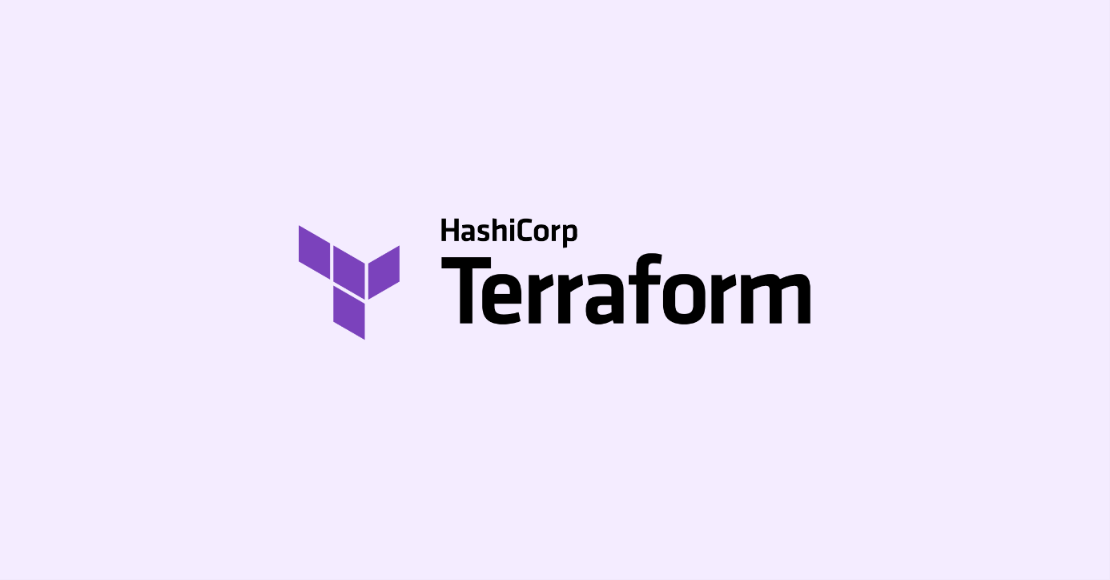

**Task 1: Familiarize yourself with HCL syntax used in Terraform**

**1.1 Learn about HCL blocks, parameters, and arguments**

HCL (HashiCorp Configuration Language) is used to write configurations. It has a straightforward syntax that allows you to define infrastructure resources and their configurations. Let's explore the concepts of HCL blocks, parameters, and arguments:

**HCL Blocks:**

* HCL configurations are organized into blocks, which are containers for other elements.
* Blocks are defined using a block type followed by an opening and closing curly braces.
* The block type represents a resource, provider, or data source.
* For example, a resource block for an AWS EC2 instance.

**Parameters and Arguments:**

* Blocks can have parameters that define characteristics specific to that block type.
* Parameters are declared within the block and can be mandatory or optional, depending on the block type.
* Arguments are used to assign values to parameters and provide specific configurations for the block.
* Arguments are defined using a key-value pair syntax.
* Here's an example of an AWS EC2 instance resource block with arguments.

Here's an example of a simple HCL block with parameters and arguments:

resource "aws_instance" "myec2" {

ami = " ami-04a0ae173da5807d3"

instance_type = "t2.micro"

tags = {

Name = "terraform-instance"

}

}

In the above example, we have a block of type "aws_instance", representing an EC2 instance in Amazon Web Services (AWS). The block has parameters such as ami, instance_type, and tags, each with their respective arguments assigned to them.

**1.2 Explore the different types of resources and data sources available in Terraform**

In Terraform, there are various types of resources and data sources available. Let's explore each of them:

1. Resources:
   * Resources represent infrastructure components that you want to manage with Terraform.
   * Each resource type has its own configuration block, parameters, and arguments.
   * Some commonly used resource types are:
     + **aws_instance**: Represents an Amazon EC2 instance.
     + **aws_s3_bucket**: Represents an Amazon S3 bucket.
     + **docker_container**: Represents a Docker container.
     + **google_compute_instance**: Represents a Google Cloud Compute Engine instance.
     + **azure_virtual_machine**: Represents an Azure virtual machine.
   * Resources are created, updated, and destroyed by Terraform based on the configuration and changes in the infrastructure.
2. Data Sources:

* Data sources allow you to fetch information from external systems or APIs to use in your Terraform configuration.
* Data sources provide read-only access to external data, which can be used to populate variables or make decisions in your configurations.
* Some commonly used data sources are:
  + aws_ami: Retrieves information about an Amazon Machine Image (AMI).
  + aws_vpc: Retrieves information about an Amazon Virtual Private Cloud (VPC).
  + docker_registry_image: Retrieves information about a Docker image from a container registry.
  + google_compute_regions: Retrieves a list of available Google Cloud regions.
  + azure_resource_group: Retrieves information about an Azure resource group.
* Data sources are defined with a data block and have their own set of parameters and arguments.

By leveraging the available resource types, you can define and manage various infrastructure components in Terraform. Additionally, data sources allow you to gather information from external systems to make informed decisions and dynamically configure your resources.

**Task 2: Understand variables, data types, and expressions in HCL**

1. Variables:
   * Variables in HCL allow you to parameterize your Terraform configurations.
   * They enable you to provide dynamic values and make your configurations reusable.
   * Variables are defined using the variable block in a .tf file.
   * You can assign default values, specify data types, and provide descriptions for variables.
   * Variables can be set via command-line flags, environment variables, or input files.
2. Data Types:

* HCL supports several data types that can be assigned to variables and used in expressions.
* Common data types include:
* string: Represents a sequence of characters.
* number: Represents numeric values.
* bool: Represents boolean values (true or false).
* list: Represents an ordered collection of values.
* map: Represents a set of key-value pairs.

1. Expressions:

* HCL expressions are used to compute and manipulate values within Terraform configurations.
* Expressions can involve variables, resource attributes, functions, and operators.
* Examples of expressions in HCL include arithmetic operations, conditional statements, and string interpolation.
* Expressions are enclosed in ${} when used within string values or as part of attribute assignments.
* Terraform evaluates expressions during the planning phase and updates the configuration accordingly.
  1. **Create a variables.tf file and define a variable**

Step 1: Create a new file named variables.tf in your Terraform project directory and Open variables.tf in a text editor.

Step 2: Inside variables.tf, let's define a variable named example_file of type string with a default value.

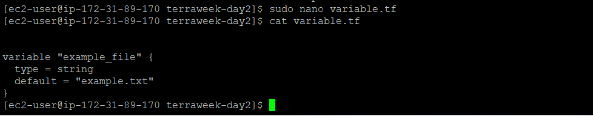

variable "example_file" {

type = string

default = "example.txt"

}

* **variable** declares a new variable.
* **"example_file"** is the name of the variable.
* **type** specifies the data type of the variable. Here, it is set to **string**.
* **default** sets a default value for the variable. If no value is provided, this default value will be used.
  1. **Use the variable in a main.tf file to create a "local_file" resource**
* Use the variable in main.tf to create an file. In your main.tf file, you can utilize the example_file variable within the "local_file" resource configuration.

resource "local_file" "myfile" {

filename = var.example_file

content = "This is an example file."

}

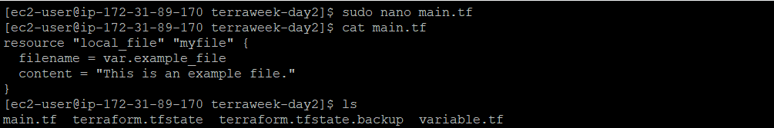

* After creating main.tf file then run the file using “terraform apply”.

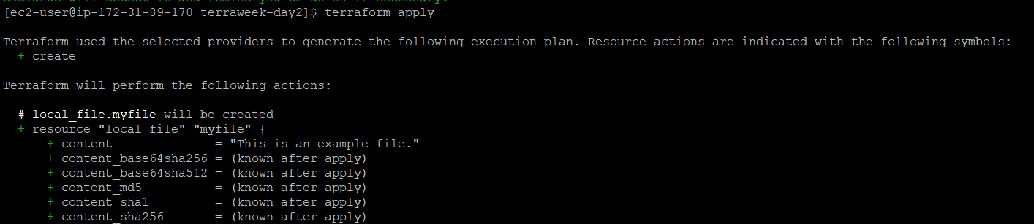

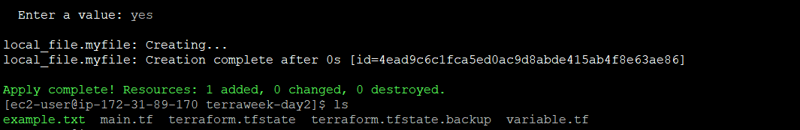

* Here you can see after apply, a file is created by name example.txt

**Task 3: Practice writing Terraform configurations using HCL syntax**

* 1. **Add required_providers to your configuration, such as Docker or AWS and Test your configuration using the Terraform CLI.**

Step 1: Create a main_1.tf file:

Create a new file named main_1.tf in your project directory and open it in a text editor.

Step 2: Add provider configuration: Inside **main.tf**, let's add the required provider configuration, such as Docker or AWS. For this example, we will add the AWS provider.

provider “aws” {

region = “us-east-2”

}

resource "aws_s3_bucket" "terraform-example" {

bucket = "terraformbucket-123"

}

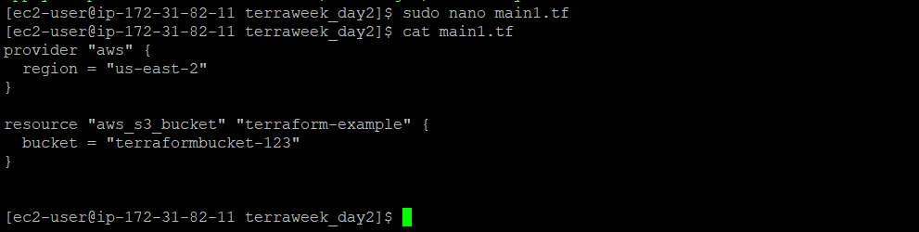

In the above example, we are adding the AWS provider configuration with the required

version.

Step 3: Save the configuration file and run **terraform init** again in the project directory. This will download and install the necessary provider plugins.

terraform init

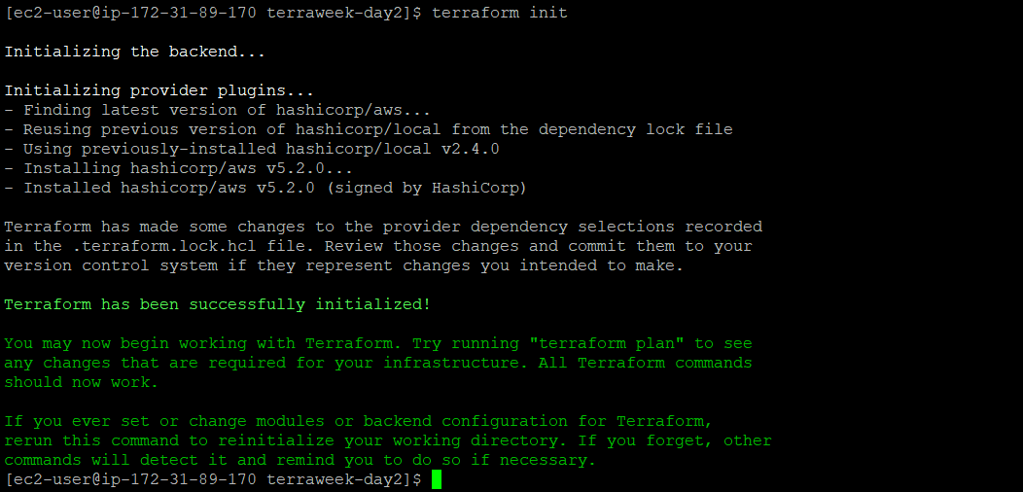

Step 4: Use the **terraform plan** command to preview changes before applying them.

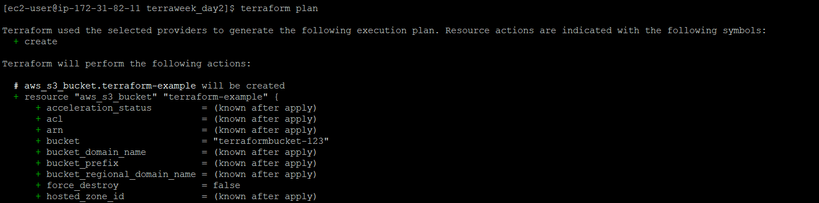

Step 5: Use the **terraform apply** the command to apply changes to your infrastructure.

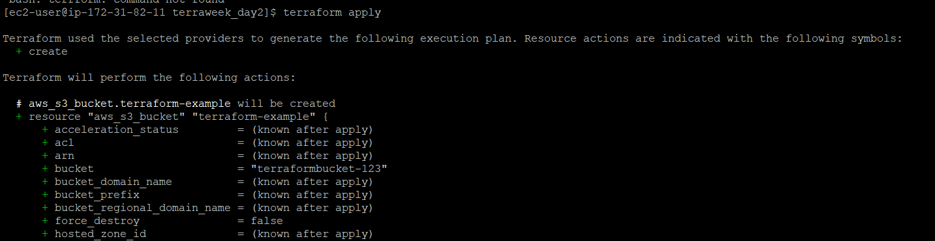



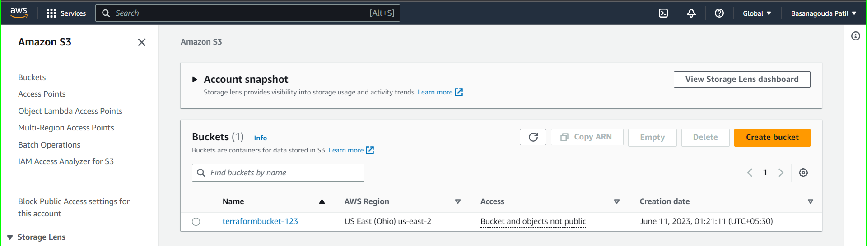

Step 6: Use the **terraform destroy** command to destroy resources created by your configuration.

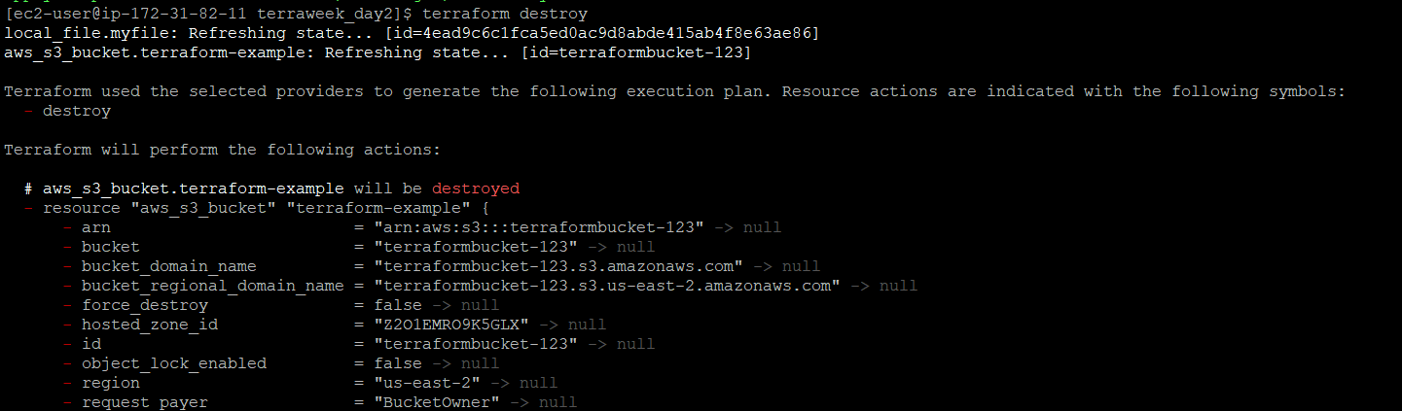



**Conclusion**:

From this blog, we learned about HCL syntax in Terraform. We explored HCL blocks, parameters, and arguments, which help structure our configurations. We also discovered various resource types and data sources available in Terraform, enabling us to manage infrastructure components and fetch external information. Additionally, we understood variables, data types, and expressions, which allow for dynamic and reusable configurations. Finally, we practiced writing Terraform configurations using HCL syntax and tested them with the Terraform CLI. This knowledge sets us up for success in provisioning and managing infrastructure efficiently with Terraform. Happy learning!

🌟 **TerraWeek Day 2 - Exploring HCL Syntax and Terraform Configurations** 🚀

In Task 1, we'll dive into the HCL syntax used in Terraform . Learn about HCL blocks, parameters, and arguments that help structure your configurations. Get ready to define infrastructure resources like a pro!

Task 2 introduces variables, data types, and expressions in HCL. Discover how to parameterize your configurations, assign data types, and use expressions for dynamic values. It's all about making your configurations reusable and flexible.

Task 3 is where the real fun begins! Practice writing Terraform configurations using HCL syntax. We'll cover everything from creating resources to testing configurations with the Terraform CLI. Let's get hands-on and build amazing infrastructure together!

In conclusion, I've learned HCL syntax in Terraform, resource types, data sources, variables, and expressions. Now I can efficiently provision and manage infrastructure with Terraform. Happy learning! 🎉 #TerraWeek #InfrastructureAsCode #Automation

Join TerraWeek challenge led by [Shubham Londhe](https://www.linkedin.com/in/ACoAABhZ4kMBt55axHJpEnVRp0UOUl-_JwwmPwk) and unlock the power of Terraform. Don't miss this opportunity to enhance your skills and boost your infrastructure management game. See you there! 👩‍💻👨‍💻

Keep learning, keep building, and share your Terraform adventures with #TerraWeek and #Terraform hashtags. Let's inspire and grow together! 💪💼

#TerraWeek #Terraform #InfrastructureAsCode #HCL #DevOps #CloudComputing #Automation #Provider #AWS #Docker